**Optimization of Cultural Trip with Tabu Search**

**1)Introduction**

The aim of this proposal is project for IE552 lesson. Project aim is optimization of cultural trip with Tabu Search. Nowadays, a lot of tourists are traveling to foreign countries and their trip route and hotel location is different. I am one of these tourists. I am planning a trip to Berlin. I have a list of cultural points of cities, but I don’t know how to schedule the best optimal way and time my cultural points. In this reason I want to applying metaheuristic algorithm which is tabu search for solving this problem.

**2)What is the tabu search?**

Tabu search is a metaheuristic search method employing local search methods used for mathematical optimization.

Local (neighborhood) searches take a potential solution to a problem and check its immediate neighbors (that is, solutions that are similar except for very few minor details) in the hope of finding an improved solution. Local search methods tend to become stuck in suboptimal regions or on plateaus where many solutions are equally fit.

Tabu search enhances the performance of local search by relaxing its basic rule. First, at each step worsening moves can be accepted if no improving move is available (like when the search is stuck at a strict local minimum). In addition, prohibitions (henceforth the term tabu) are introduced to discourage the search from coming back to previously visited solutions.

The implementation of tabu search uses memory structures that describe the visited solutions or user-provided sets of rules. If a potential solution has been previously visited within a certain short-term period or if it has violated a rule, it is marked as "tabu" (forbidden) so that the algorithm does not consider that possibility repeatedly.

**3)What is my trip route problem?**

Figure 1:City Points

Figure 2:Points Name and Number

In Figure 1 and Figure 2 is the point of cultural place of Berlin City. I want to prepare a plan for the trip for all these points. I just know my hotel location, which is the starting point and these cultural points which are in Figure 2. I chose the tabu search solution for finding the optimal routing of cultural points.

**4)What is my solution to my problem?**

I will prepare a table of cultural places represented in Figure 1 and Figure 2. This table includes cultural point number and distance of each place. Ordering to place number, tabu structure will be filled with distance of each two points.

Figure 3:Tabu Search Structure

This tabu search algorithm helps me making to optimal trip route with minimum effort. I will use these methods of flow chart (Figure 3).

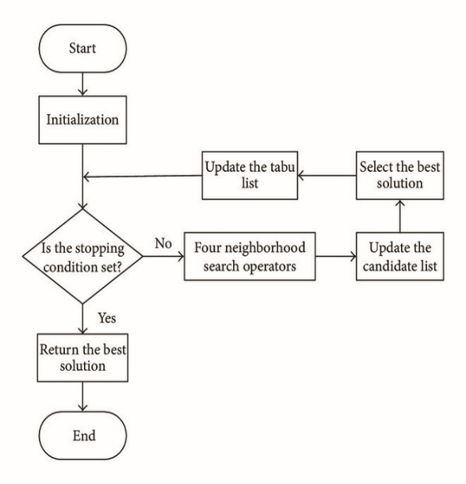The initialization part is defining the route points and giving to algorithm. Then I will look at all distances between each cultural point. In this way, I will find the best solution for the shortest and optimal distance between two points. After all the measurements, I will decide the best trip route.

**5)Same examples with My Project**

Prof.Dr. Muzaffer Kapanoğlu who is a head of Eskisehir Osman Gazi University Informatics Department is solving a random example in this video

(<https://www.youtube.com/watch?v=uM66mTBtXco>).

His random example has some same side with my trip problem. I will use the same solution way for solving my problem.

**6)Another Algorithm for Solving Problem**

Algorithm 1: If changing the trip schedule like as factory or delivery servicing. This problem is evaluated as vehicle routing problem. I will define a starting point that is my hotel and I define a customer point which is my cultural place. In this way, I can use Vehicle Routing Problem solutions to my problem.

Algorithm 2: I can use the greedy algorithm. I can start to my hotel and choose a finish point between these cultural points (figure 2) then I define the cultural point value in respect to preference points which is taken TripAdvisor. Different distance could be taken in the google maps with choose different station between start and finish points.

Figure 4:Tabu Search Flowchart

Berkay Ergün

202171003